Alza Council
Wednesday, October 1, 2025, 11:30 a.m. – 1:30 p.m.

In lieu of our regular Alza Council meeting we invite you to join in the Lobo Pride Celebration to kickoff LGBTQ History month.

Hope to see you at 11:30 at the Scholes Hall Flag Poles and to continue the celebration with a march to the Cornell/SUB Mall for music, snacks, and entertainment.
See flyer below for more information.

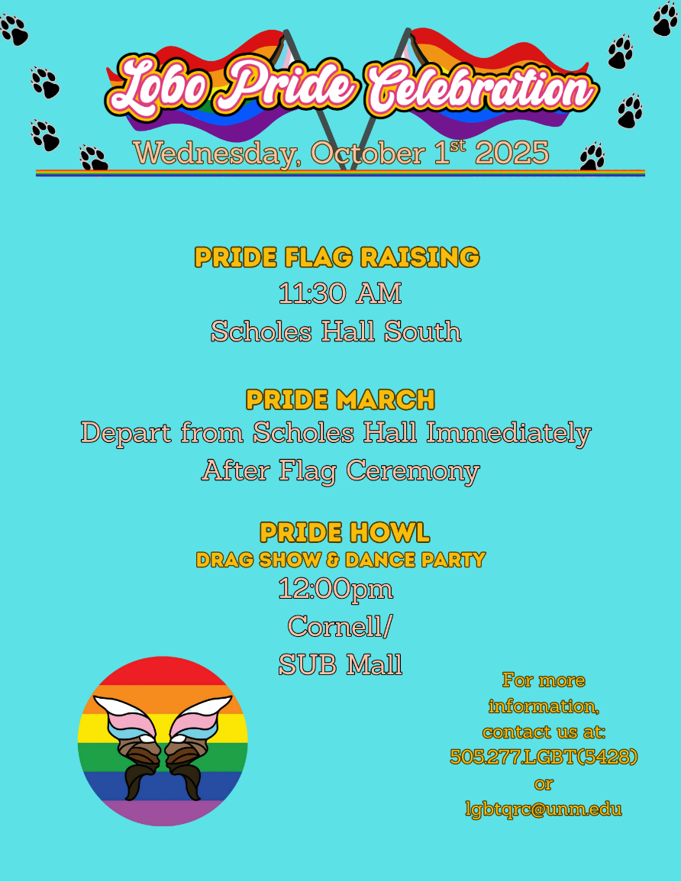

1:30p Adjourn

Next meeting: November 5, 2025 in Roberts Room

